**Kubectl:** - CLI to configure Kubernetes and manage apps

**Node:** - Single Server in kubernetes cluster

**Kubelet:** - Kubernetes agent running on nodes

**Control Plane:** - Set of containers that manage the cluster. It includes API Server, scheduler, controller manager, etcd and more. Sometimes it is called as Master.

Kubernetes is a series of containers, CLI’s and configurations.

**Practice Kubernetes online**

Play-with-k8s.com

Katacoda.com

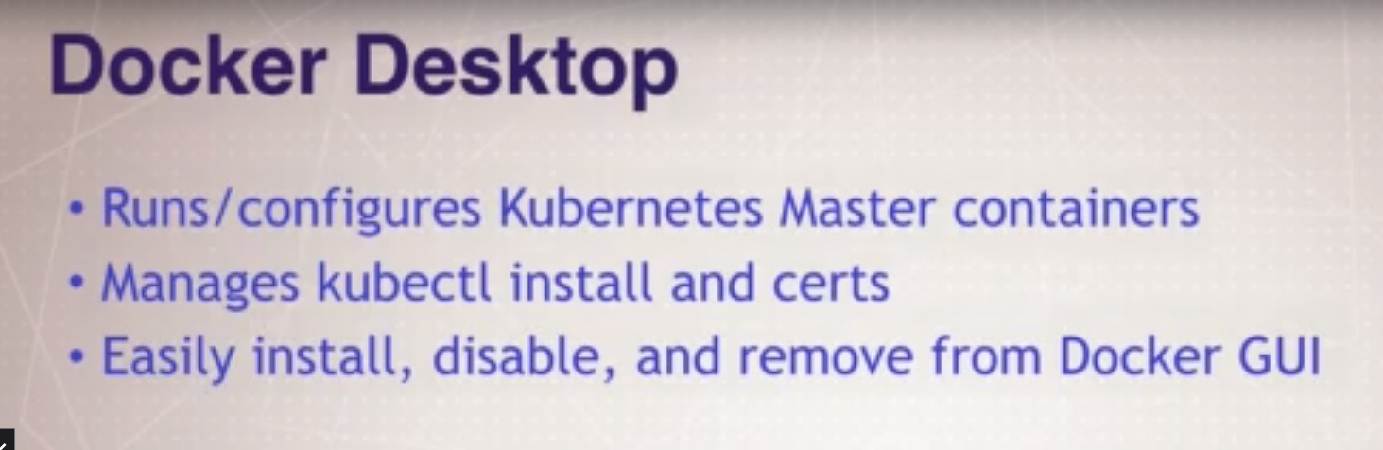

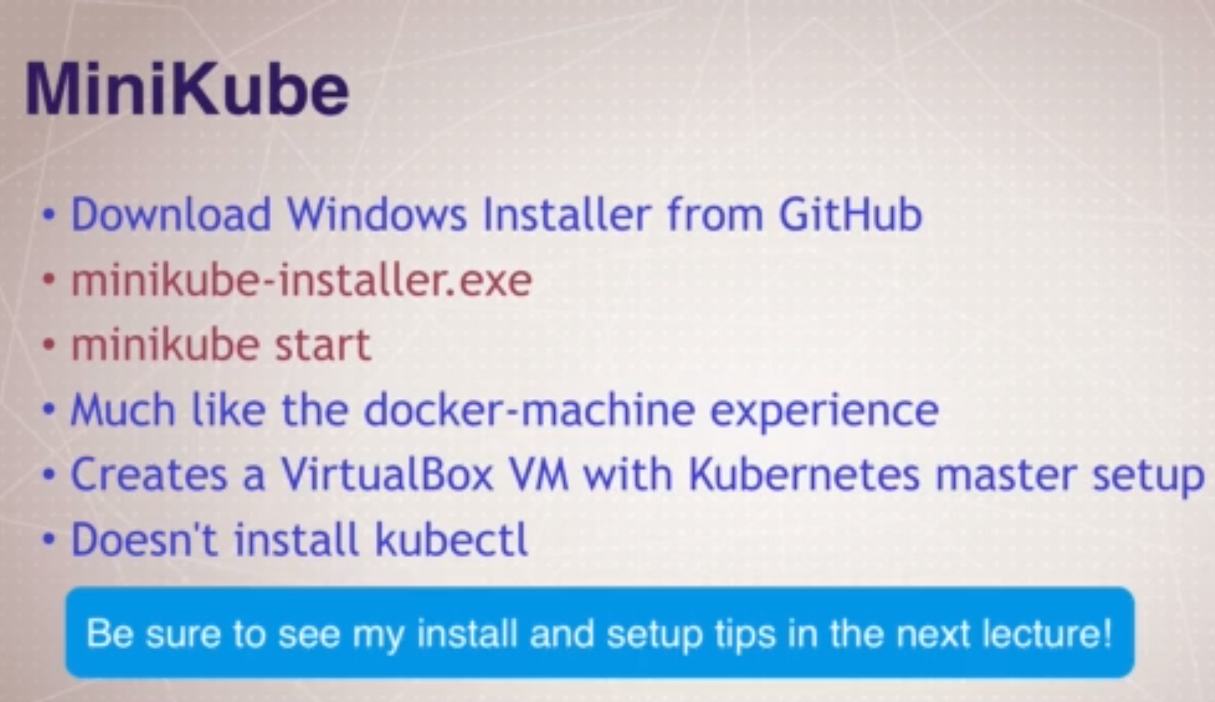

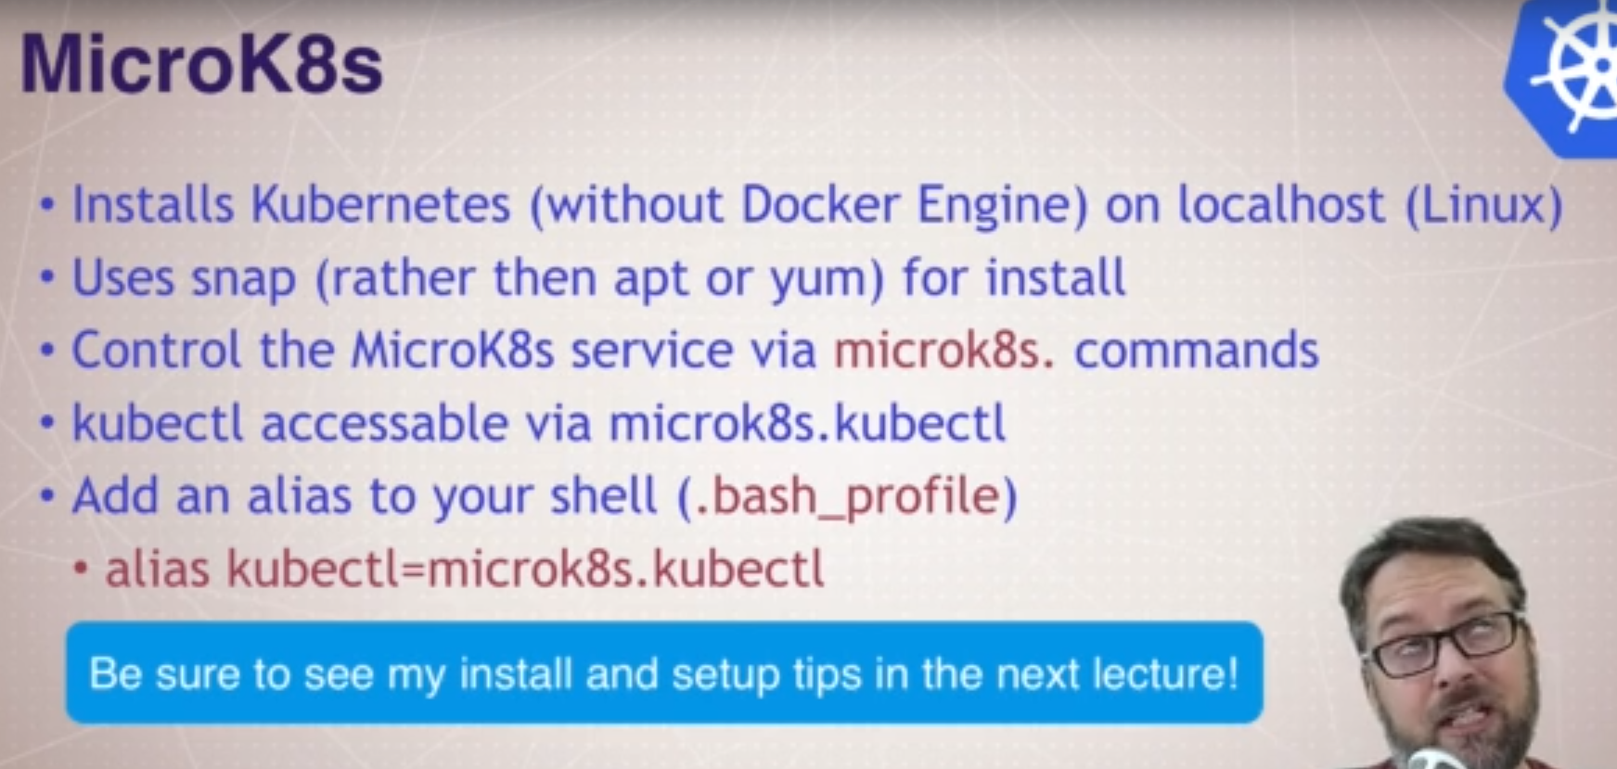

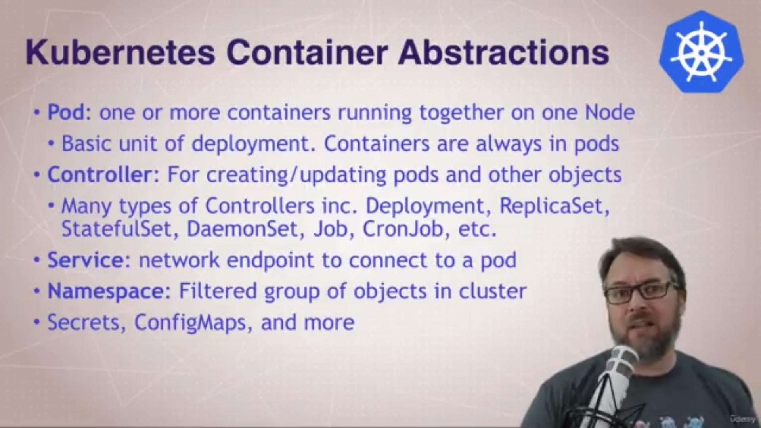

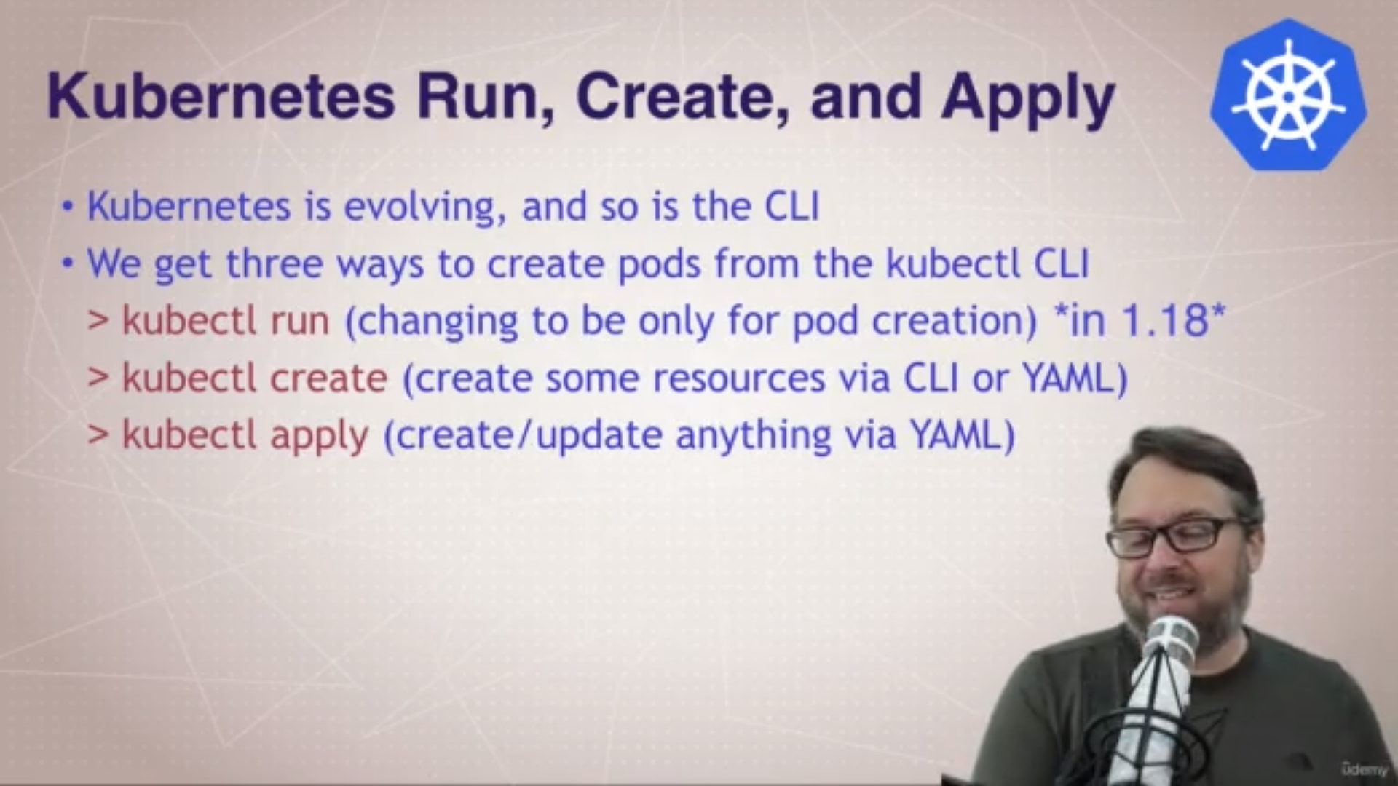

**kubectl version:** - This command is use to find kubectl version of client and server.

**kubectl run <pod/container name> --image <image-name>**

**kubectl run my-nginx –-image nginx** :- This command use to create pod. This command by default creates many things like Deployment, ReplicaSet, Pod.

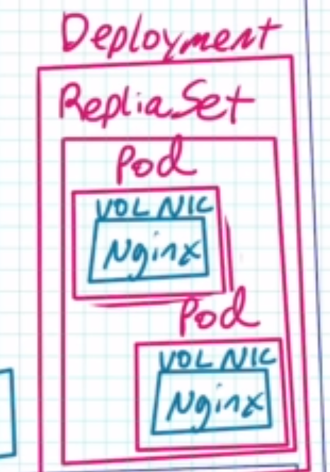

**kubectl get pods :-** Show all PODS.

**kubectl get all :**- Show all services like POD, Services, Deployment, ReplicaSets, etc.

**kubectl delete deployment <pod/container name>**

**kubectl delete deployment my-nginx** :- This command will delete all Deployments, Replica Sets, Pod inside specified name.